Year1

Report-Project3

*SEQUENCE OF CHAIN REACTIONS*

**Submitted by:**

Komiljonov Bobur U1910275(19-03)

Kholmurodov Dilshod U1910232(19-03)

Naimov Fayyoz U1910071(19-02)

Mirsagatova Sitora U1910245(19-03)

Zaynobiddinova Zebiniso U1910278(19-03)

|  |  |
| --- | --- |
| *Team N: 07*  *Team Name: Gravity* |  |

School of Computers and Information Engineering



ABSTRACT.

This report form is about the sequence of chain reaction that we had constructed using our own ideas. This sequence ended with falling off the egg to the special box. The sequence included several chains and different objects. Since we are in quarantine, we used only objects that we have at our homes.

CONTENTS

ABSTRACT………………………………………………………………………………………………………………………………2

CONTENTS………………………………………………………………………………………………………………………………2

Introduction……………………………………………………………………………………………………………………2

Structure of report…………………………………………………………………………………………………6

Gantt Chart………………………………………………………………………………………………………………………7

Conceptual Design Project Flow……………………………………………………………………11

Evaluation and Analysis………………………………………………………………………………………14

Decision-Making Matrix…………………………………………………………………………………………15

Final Design……………………………………………………………………………………………………………………16

Conclusion…………………………………………………………………………………………………………………………17

INTRODUCTION.

The chain action we have created triggers different events with different objects. We have mainly used things that we see in our daily life. Those are cards, books, toys, dominos, little balls and some minor stuff. Each object plays its role in the chain action. And if one of those items goes in a wrong way, the whole action will be destroyed. Creating this kind of chain action took a long time, and multiple retries. We tried to create something eye catching with the help of regular and ordinary things and you can see the ready result.

STRUCTURE OF REPORT.

In this report the steps of the conceptual designing process will be given in the following order:

1. Gantt Chart
2. Conceptual Design Project Flow
3. Evaluation and Analysis
4. Decision-Making Matrix
5. Final Design

GANTT CHART.

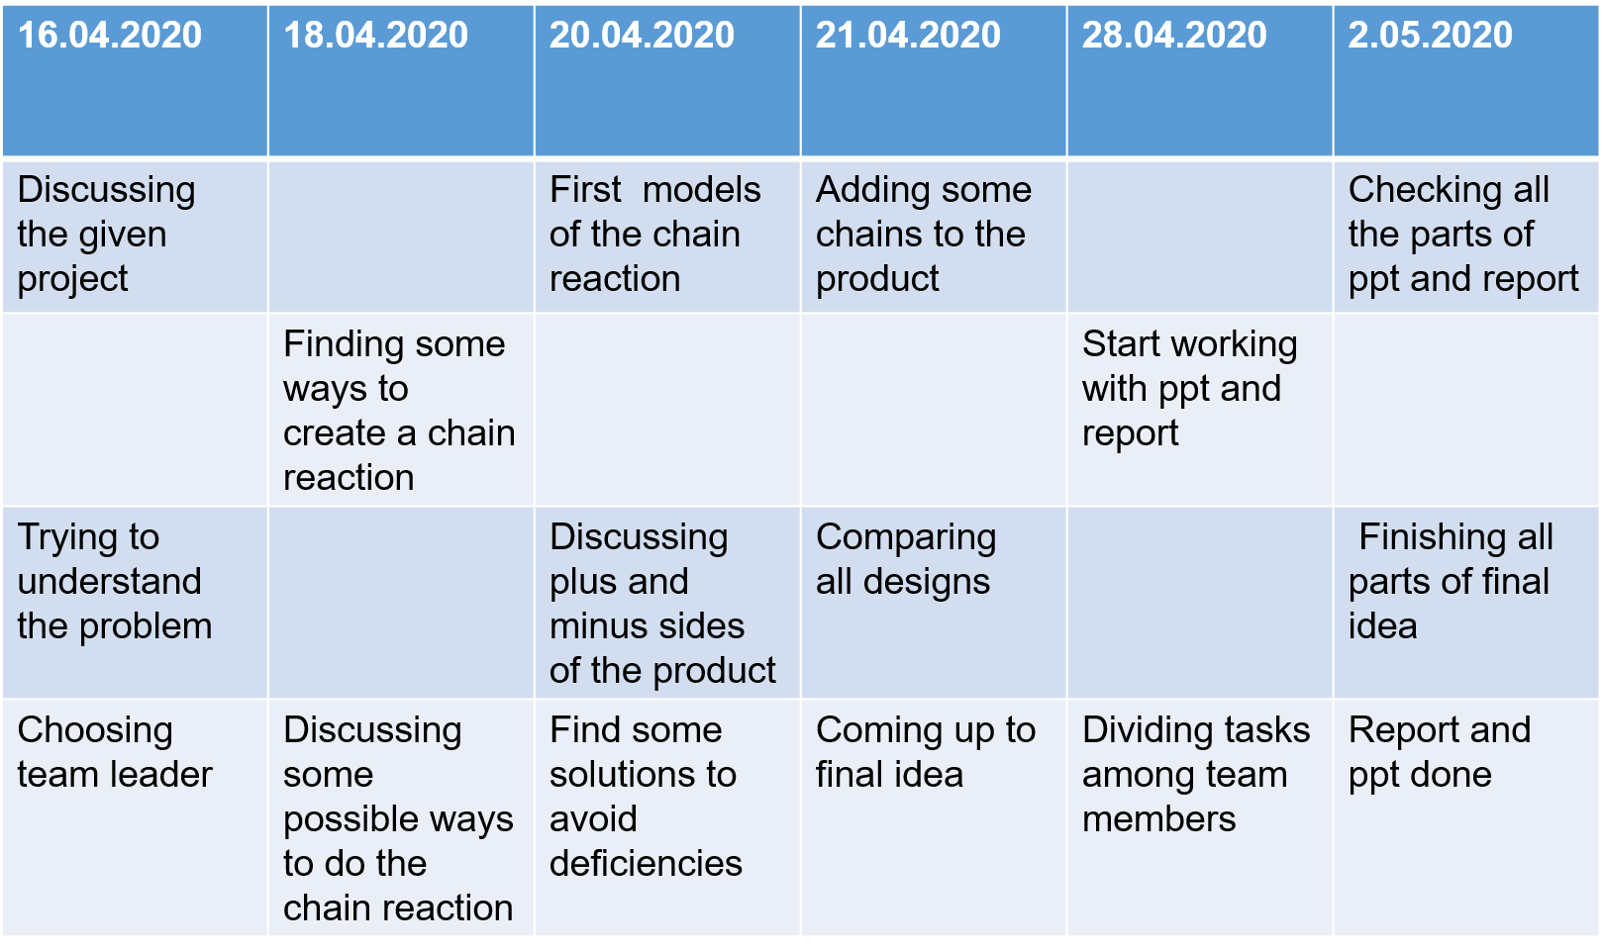

Conceptual Designing Process lasted 17 days, in which 3 online Meetings and a General Meeting (online meeting using ZOOM) was held.



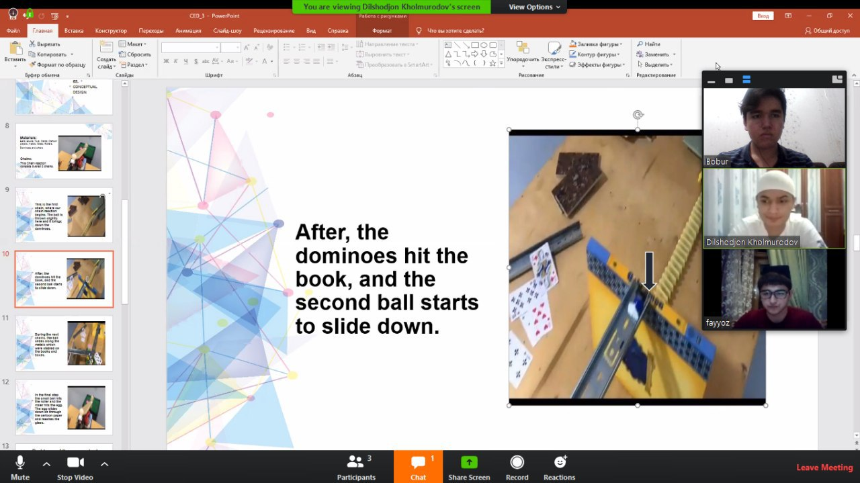

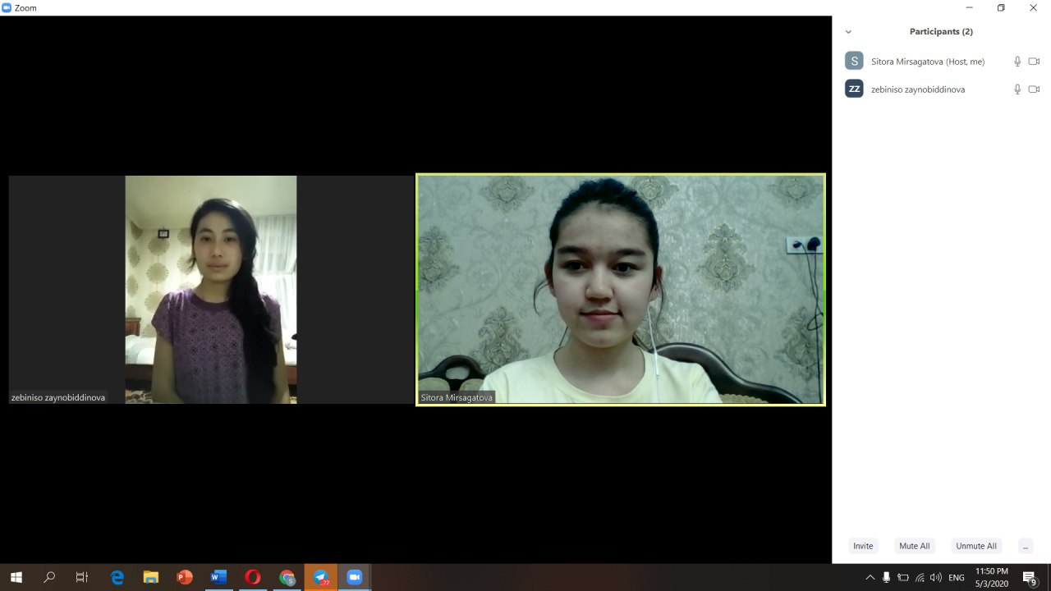

CONCEPTIAL DESIGN PROJECT FLOW.

In the beginning of project 3, we first made the sequence that consisted of few chains. Actually, we were required to start our chain from the given height and end our chain with falling an egg to the box. We used only everyday objects that every person has at their homes. We didn’t spend any money to this product, since all the required things are taken from the home. After several online meetings, we added some more chains to our sequence and finalized our video. One member of our group did it at her home, and we together discussed about the chains that we should add to our sequence.

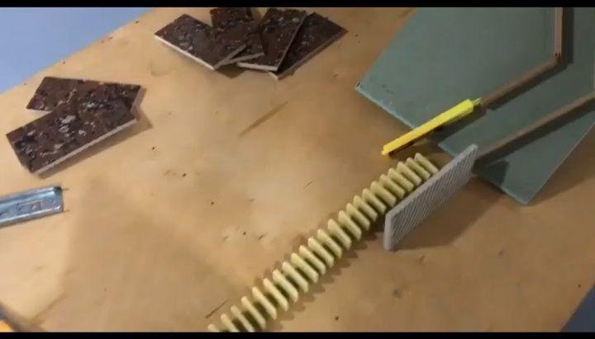

This is the first chain, where our chain reaction begins. The ball is thrown slightly here and it brings down the dominoes.

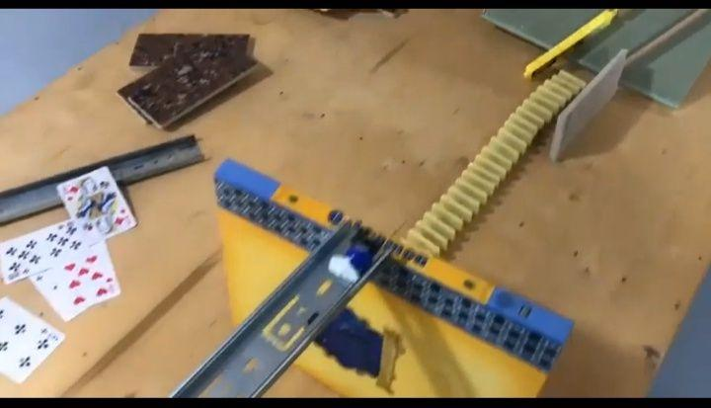

After, the dominoes hit the book, and the second ball starts to slide down.

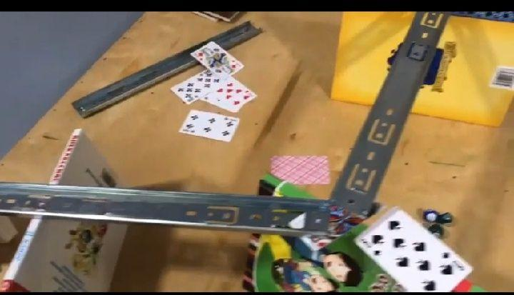

During the next chains, the ball slides along the metals which were stabled on the books and boxes.

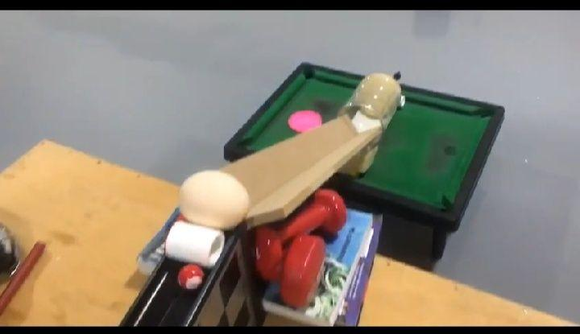

In the final step the small ball hits the roller and the roller hits the egg. The egg slides down on through the cartoon paper and reaches the glass.

MATERIALS FOR OUR PRODUCT:

 Table Tennis ball

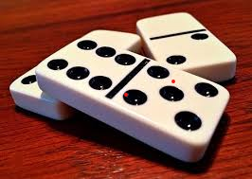

Dominoes

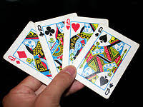 Game Cards

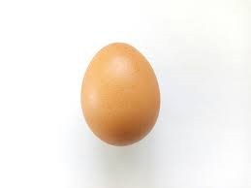 Egg

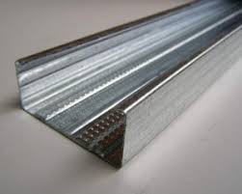 Profile

When it comes to materials, you see that it doesn’t need a lot and expensive materials to make. If we trust our calculation that 8metres of stainless profile and 2packages of welding electrode are enough to make ready for sale. And I think more people know that materials are durable and stainless.

Evaluation and Analysis.

1) Some problems of the conceptual design were successfully solved in the final design or in creation process.

2) Chain reaction was done successfully using household items and toys. No money was spent in creating process and still we have achieved the desired result.

3) Materials were chosen correctly and placed with clear and logical order in order to interact with each other correctly and to get overall one connected and live action.

4) Creativity lead to create a chain reaction which fulfills the purpose. Luckily, after a long time of creation process, the result was worth the time spend on it.

DECISION MAKING MATRIX.

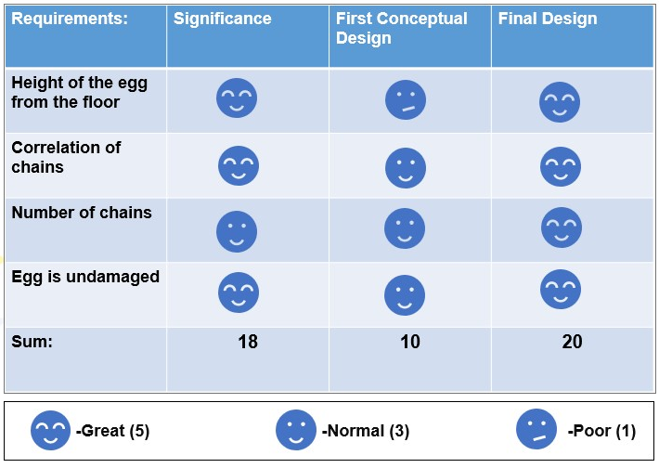

In our decision-making matrix, we compared actually three things by 3 factors. The first thing is the requirements that we were asked and the importance of them. The second thing is our conceptual design that had some minor technical problems. And the last thing we compared is out final sequence of chain reactions. The requirements that we should have strictly followed were height of the egg from the floor, correlation of chains, number of chains, and undamaged egg. We successfully met all the requirements at the final design.

FINAL DESIGN.



First chain

The ball will be thrown and it slides along the way, causes dominoes to fall

 Second chain

Dominoes push the book. Then the next ball begins to move



Third chain

Ball slides along the way made with metals.

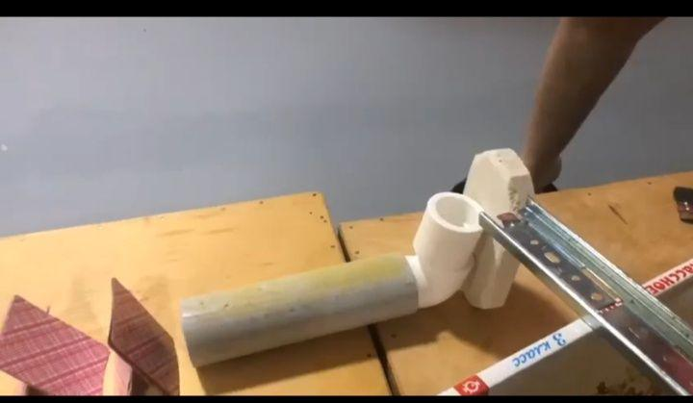

Fourth chain

The ball comes along the way, and falls into tube.

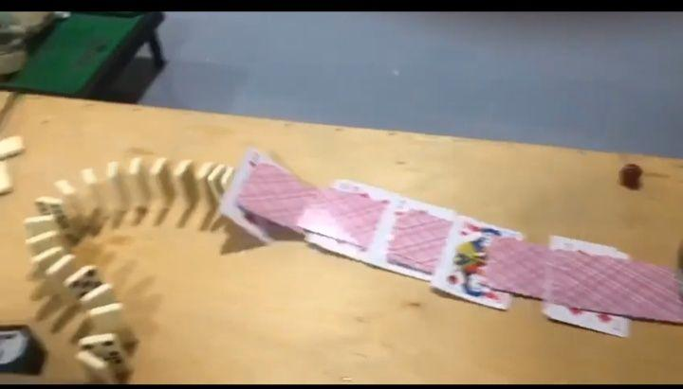

Fifth chain

Ball comes from the tube and causes the cards to fall, the cards causes the dominoes to fall

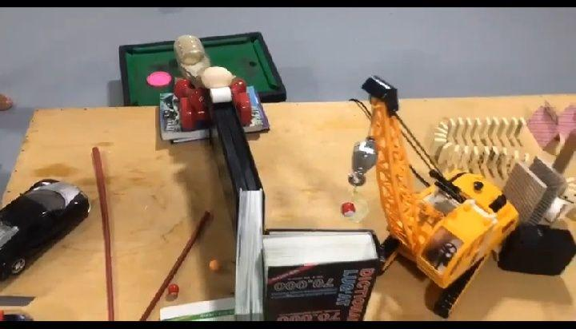

Fifth and sixth chain

Dominoes push the wood which makes the excavator to work. Excavator throws the ball; the ball moves along the way made with book and box



Final chain

In the final chain, the red ball pushes the roller and the roller pushes the egg. The egg slides down along the way made of the cartoon paper and reaches the glass. The egg will not get damaged during the whole process.

The height of the starting point is 35 sm.

The distance from starting point to the end is 2 meters

The egg is around 80 cm from the ground

CONCLUSION.

In this event, we came up with our own chain action idea and tried to realize it with the help of things that we saw near us. The most complicated part was the creating process. It took a lot of time and there were couple of different fails. Sometimes the cards just fell down and destroyed the whole process before we even could make a video of it. In other tries the action just stopped because of one little mistake that was not seen. However, after multiple times we managed to make the setup ready to film and accomplished our plan.

The action starts with the little ball that fired by the person, then it reaches some dominos that pulled each other. It eventually triggered the ball that roll over some metal path and pulled some cards placed in order. The action again went to dominos and they triggered the toy that gave the action to the next ball. Finally, that ball roll down its way and put the egg inside bottle. That was the final action that we expected to see. The result was pretty much the same with our expectations.